Installing Solo Dock Stairs
4 Step Stairs: Minimum 36” from top of dock to lake bottom
6 Step Stairs: Minimum 48” from top of dock to lake bottom
Due to the weight of the 6 step stairs, you will likely need two people to carry the stairs into the water and attach it to the side of the dock.
The first step is to bolt the footpads to the short posts using the included stainless steel footpad bolts. Install the posts into the Leg Locks at the bottom of the stairs.
Next, install the handrail into the Leg Locks welded to the side of the stair frame, and tighten the Leg Lock bolts.
Now carry the stairs into the water and hang the adapter bracket that is integrated into the top of the frame on the long side of one of the dock sections. Install bolts, nuts and retainer brackets through the holes on the bottom of the adapter bracket. Tighten nuts firmly but do not over-tighten.
Adjust the footpad posts on the bottom step so they firmly support the bottom of the stairs on the lake bottom. Install vinyl caps on the footpad posts.
 | Retainer Bracket Under Dock Frame:
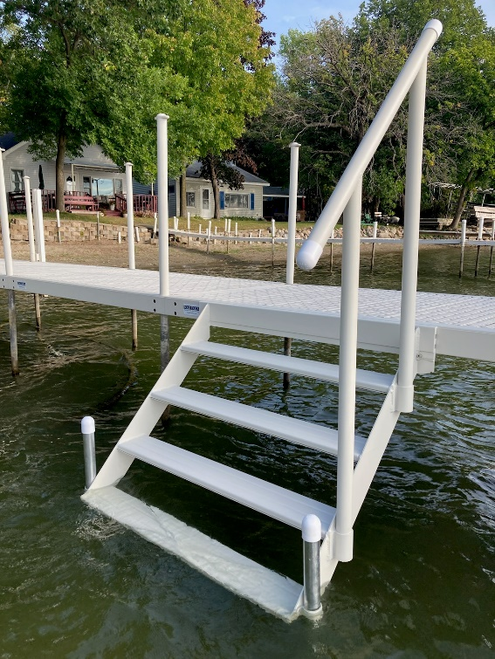 | 