Solo Dock Deepwater Bracing Pipes & Quick Attach Brackets
Installation Instructions
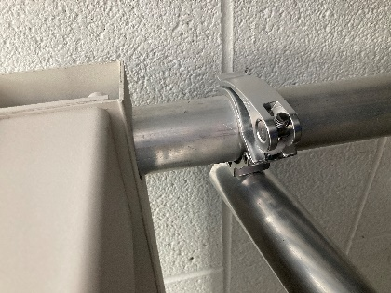 | Install from the dock surface or from the water on the short side of the dock.  First hang the right side of the Deepwater Bracing Pipe loosely on the right side of the dock frame.  Tighten or loosen the brackets by opening the clamp and turning the handle clockwise to tighten and counterclockwise to loosen.  Install the bracket on the left side around the dock pipe.
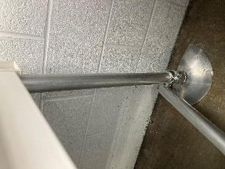 | Keep the bracket just loose enough that you can move the bracket, and push the bracket down to the footpad.
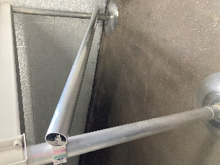 | Install the clamp on the right dock post.  The Deepwater Bracing Pipe can be installed with the clamps facing inward or outward.
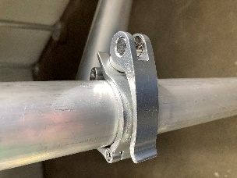 | The Deepwater Bracing Pipe is supplied with a 6’ heavy duty 1/8” wall aluminum dock pipe. It does not need to be secured right at the bottom of the dock decking to work effectively. If the pipe is too long, remove the bracket from the pipe, cut the pipe to length, drill a hole in the pipe and re-install the bracket using the supplied stainless steel bolt and nut.
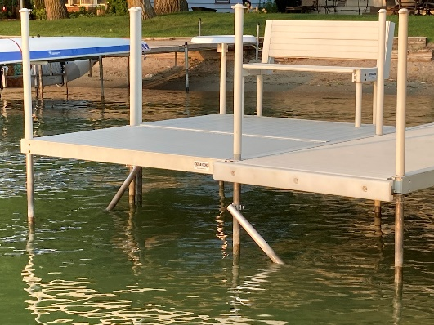 | Solo Dock  Deepwater Bracing Pipe With Quick Attach Brackets  www.SoloDock.com  Easy@SoloDock.com  952-472-3953

