Solo Dock Screw Legs
- Adapt your current dock posts to screw legs.
- Fits all Solo Dock frames.
- Fits any dock post bracket with 1 ¾”-2” dock pipe.

The Solo Dock Screw Leg can be extended up to 16”, and installs into the dock section Leg Lock through the underside of the dock section, just like a dock post.

The screw leg is intended to make it easier to level dock posts in deck areas or locations where the Leg Lock bolt access hole is covered up by a Side Mount Hinge or another dock section.

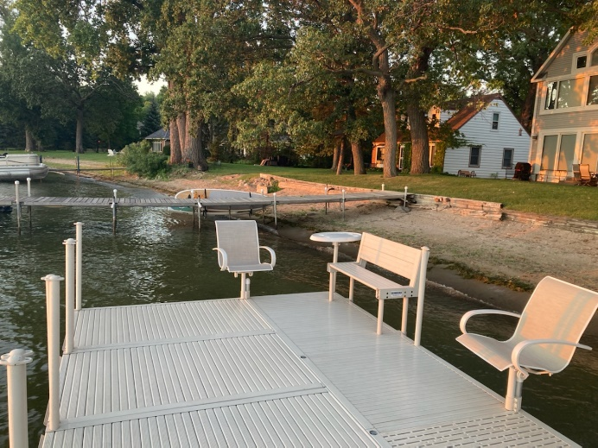

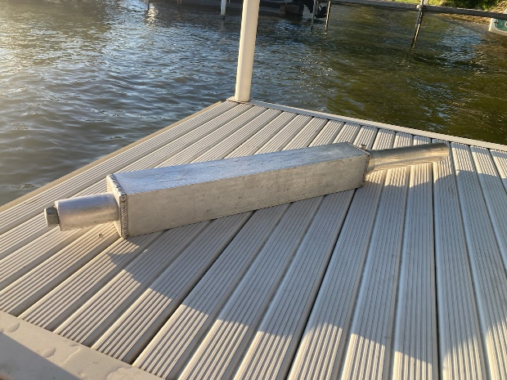 | 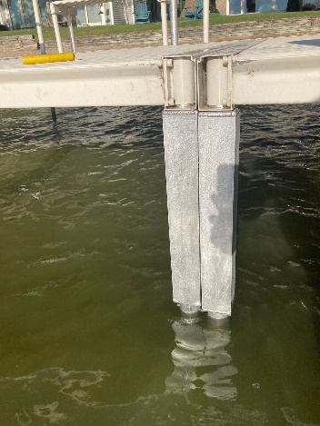 | 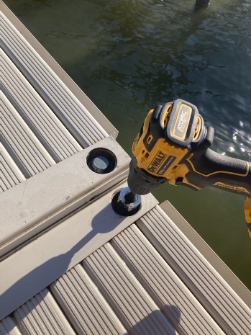

Sizing Pipes and Installing Screw Legs
Assumptions:
*Bottom of the dock is installed 18” above the water.
*Dock post length calculation allows for the water to be up to 4 inches lower during installation next spring.
*Water depth measurement includes water and muck depth.
*Pipe length calculation also allows for the height of the footpad base, length of the screw leg when fully retracted to its shortest length, and dock pipe being inserted into the screw leg pipe.

- Measure the water+muck depth at the location of each screw leg.
- Subtract 8”
- Cut dock pipe length to water depth – 8”.
Example: Water Depth 36” – 8” = Pipe Length of 28”

For new docks, bolt a footpad to the dock post using the pre-drilled hole on one end of the dock post, using the included ¼” stainless steel bolts and stainless steel lock nuts.

Next, slide the short 3” pipe included in your kit over the other end of the dock post. Insert the 3” pipe and dock pipe into the pre-drilled pipe extending from the bottom of the screw leg.

If using a half-footpad, position the flat side of the footpad in line with the side of the dock section.

Using a ¼” drill bit, insert the drill bit into the hole in the 3” pipe and drill a hole through the dock pipe. Do the same for the other hole on the other side of the 3” pipe.

Insert a ¼” stainless steel bolt through all three pipes and install a stainless steel lock nut.

To extend the screw leg (making the dock post longer) turn the nut on the top of the screw leg counter-clockwise to the left. To retract the screw leg (making the dock post shorter) turn the nut on the top of the screw leg clockwise to the right.

Use a 15/16” socket and a cordless drill socket adapter installed in a cordless drill to raise and lower the screw leg. Set the drill initially on a slow setting.

Insert the 3” pipe on the top of the screw leg through the bottom of the dock frame into the Leg Lock. Tighten the Leg Lock using a T handle wrench.

Repeat this process for the other dock post, and then install the dock section as usual.

Each spring, before installing your screw legs, run the screw all the way up and down two times to clean the threads of any dried debris.

Revised 4/28/23

