Bench Installation Instructions
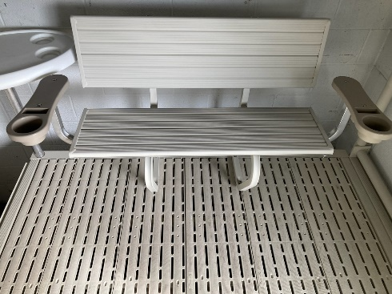
Bench Installation:
4 bolts 3/8” – 16 x 3” stainless steel
4 large washers 3/8” x 1”
2 large washers 3/8” x 1 ½” for Titan deck boards on Solo Dock Flex docks.
2 small washers 3/8” x 5/8” under dock frame flange on Solo Dock Flex docks.
4 3/8”-16 stainless steel non-locking nuts

Set the dock section and bench on sawhorses or supports on shore and drill and install the bench as directed below. Then, remove the bench, install the dock section in the lake, and re-install the bench.

Solo Dock Flex With Titan Poly Decking:
- Position (and center if desired) the dock bench on the 6’ side of dock frame. When centered, the outside edge of each bench frame bracket will be 26 5/8” from the edge of the dock frame.
- Mounting holes are pre-drilled in the bottom of the frame brackets. Position the holes in the front of the brackets so the supplied 3” bolts will drop through the decking in the decking holes/slots.
- Using a 3/8” drill bit, insert the drill bit through the holes on the rear of the bench frame and drill through the decking and the recessed dock frame flange that supports the deck panels.
- Slide a large 1” diameter washer over each bolt and install 3” bolts in all 4 holes.
- Install small 5/8” diameter washer and nut on bolts on the back of the bench extending through the dock frame flange.
- Install large 1 ½” washers and nuts on the bolts in the front of the bench frame brackets, under the Titan decking.

Solo Dock With Integrated Aluminum Decking:
- Position (and center if desired) the dock bench on the 6’ side of dock frame.
- Mounting holes are pre-drilled in the bottom of the frame brackets.
- Ensure that the holes will be drilled between the ribs on the underside of the decking. Measure, or drill very small pilot holes if necessary.
- Using a 3/8” drill bit, insert the drill bit through 4 holes on the bottom of the bench frame and drill through the aluminum decking.
- Slide a large 1” diameter washer over each bolt and install 3” bolts in all 4 holes.
- Install small 5/8” diameter washers and nuts on bolts on the underside of the dock decking.
- Tighten nuts snugly, but do not over-tighten to prevent damaging the stainless steel threads.

