Installing and Removing a Solo Dock Flex

Installation  Follow the Solo Dock installation instructions to install the Solo Dock Flex frame with posts and footpads. Use the Dock End Bracket from the Removal Winch (with a rope tied to it) to lower the Flex frame into the water. If the frame is resting at more than a slight angle up or down, pull the frame back up and re-adjust the posts. This will make it easier to fine-tune the level of the dock after the panels are installed. | 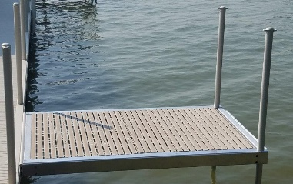
Next, install the Titan poly panels.  There are two panels that are slightly different lengths. When you install the panel, looking out toward the middle of the lake, you should be able to read the Titan logo.  First install the smaller panel that is 32 3/16” long, and push it to the post end of the dock section. Then install the larger panel that is 42 ¾ inches long on the end of the dock section nearest to you.  The panels will overlap as shown in the photo to the right.  Now, remove the Dock End Bracket and level the dock section using the Leveling Winches. | 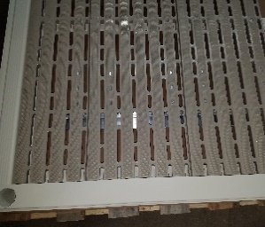  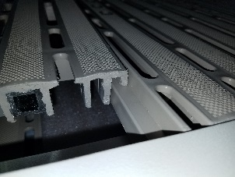  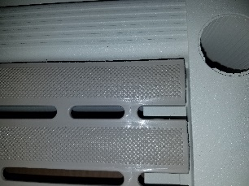
Retainer tabs are pre-installed in each panel. These tabs keep the panels in place if you have high waves, wind or storms. The tabs are optional and can be removed. After the panels are installed, the tabs can be adjusted by reaching under the dock section and turning the tab screws with a screwdriver in or out to get the right fit. Then simply rotate the tabs to catch on the aluminum panel supports on the dock frame.
If your panels fit too tightly or loosely in the Solo Dock Flex frame, the size of each panel can be adjusted. Each panel is assembled with three boards, which are secured with an aluminum support. The support has slotted holes, allowing you to shorten or lengthen the panel based on expansion or contraction of the poly material that naturally happens as temperatures change. During assembly, the boards are spaced 3/8” apart, and can be easily adjusted. | 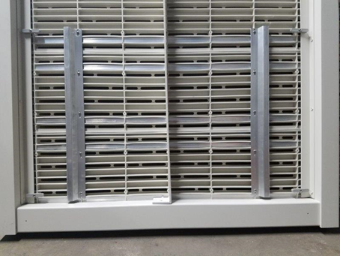
Removing a Solo Dock Flex  To remove Solo Dock Flex dock section, first reach under the dock section and turn the tabs so the panels can be removed. Then set up the Removal Winch one section back from the dock section to be removed. Install the Removal Winch End Bracket on the end of the section to be removed. Then remove the Titan poly panels. After the panels are removed, take the Solo Dock Flex section out as recommended in the main removal instructions. The panels can be stored on the frame to save space, or stacked separately. | 